kevalvyas79@outlook.com
[Company name] [Company address]
Windows Service & Process Monitoring Agent

keval vyas

1. Project Overview This project focuses on building a Windows Service & Process Monitoring Agent capable of detecting malicious, unauthorized, or suspicious process behavior . Windows processes are common targets for malware, which often uses "Parent-Child" relationships (like Word opening PowerShell) to execute attacks stealthily .
The monitoring agent analyzes runtime activity to identify anomalies, audit startup services, and detect unauthorized processes running on the system .

2. Objectives The primary objectives of this project are:
- To monitor active Windows processes and analyze parent-child behavior.
- To audit startup services for newly registered or suspicious entries.
- To detect unauthorized processes based on known threat patterns.
- To generate alerts and detailed reports for forensic analysis .

3. Workflow The agent follows a cyclic monitoring process:
- Enumerate Processes: Scans all active Process IDs (PIDs) and Parent PIDs .
- Build Tree: Constructs the parent-child relationship hierarchy.
- Analyze Behavior: Compares relationships against a "Suspicious Chains" database (e.g., winword.exe spawning cmd.exe).
- Alerting: If a match is found, it logs the threat and alerts the user.
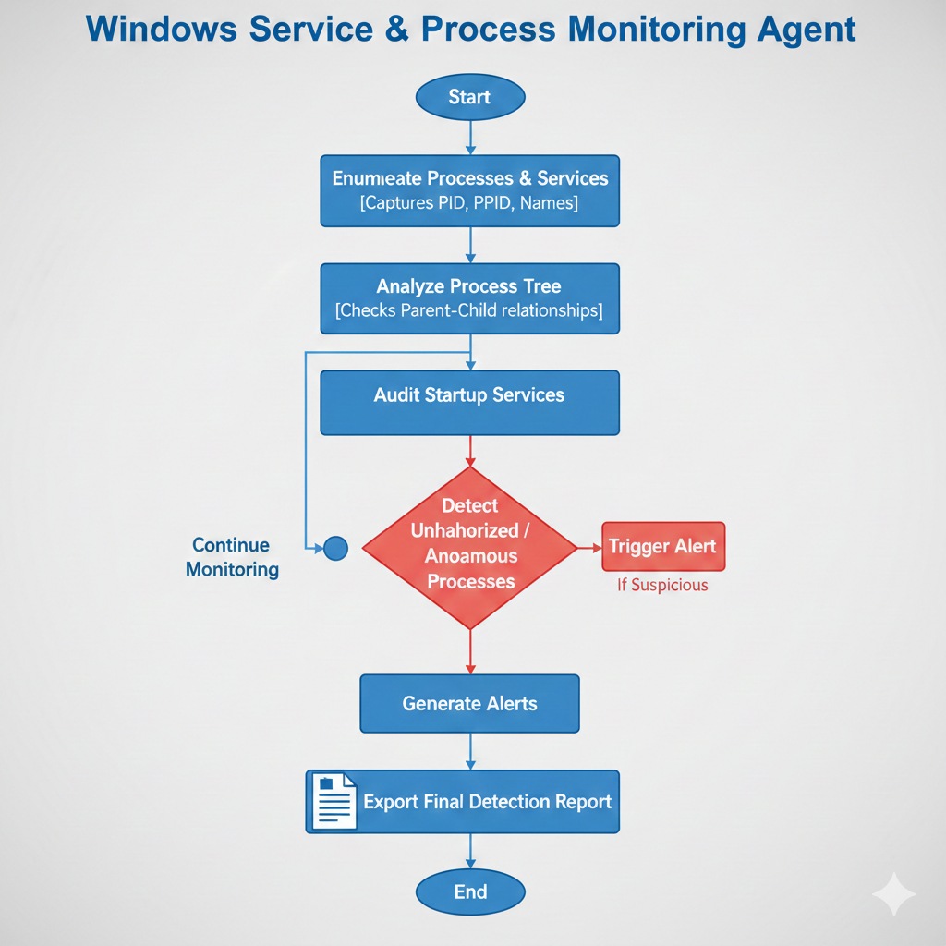

4. Tools & Technologies The project is implemented using Python for its powerful system interaction libraries.
- Libraries: psutil (for process enumeration), datetime (for logging), time (for scheduling scans) .
- Logic: The script uses a dictionary map to link every Child Process to its Parent Process name to detect anomalies.
- Python Code Logic The agent defines a list of SUSPICIOUS_CHAINS (Indicators of Compromise). It continuously scans the system process tree and flags any behavior matching these rules.
Process_agent.py code:
import psutil
import datetime
import time
import os

# --- CONFIGURATION ---
LOG_FILE = "process_alerts.txt"

# SUSPICIOUS PATTERNS: [Parent Process, Child Process]
# Example: If 'winword.exe' spawns 'cmd.exe', it's likely a macro virus.
SUSPICIOUS_CHAINS = [
("winword.exe", "cmd.exe"),
("winword.exe", "powershell.exe"),
("excel.exe", "cmd.exe"),
("excel.exe", "powershell.exe"),
("explorer.exe", "powershell.exe"), # Sometimes suspicious
("chrome.exe", "cmd.exe")
]

def log_alert(message):
"""Saves alerts to file and prints them"""
timestamp = datetime.datetime.now().strftime("%Y-%m-%d %H:%M:%S")
full_msg = f"[{timestamp}] {message}"
print(full_msg)
with open(LOG_FILE, "a") as f:
f.write(full_msg + "\n")

def get_process_tree():
"""Scans all active processes and their parents"""
processes = []
try:
# Iterate over all running processes
for proc in psutil.process_iter(['pid', 'name', 'ppid']):
try:
processes.append(proc.info)
except (psutil.NoSuchProcess, psutil.AccessDenied):
continue
except Exception as e:
print(f"Error scanning processes: {e}")
return processes

def analyze_behavior():
"""Checks for bad parent-child chains"""
print("[*] Scanning Process Tree for Anomalies...")

# Get all current processes
all_procs = get_process_tree()

# Create a dictionary for quick lookups {pid: name}
proc_map = {p['pid']: p['name'].lower() for p in all_procs}

found_threat = False
for p in all_procs:
child_name = p['name'].lower()
parent_pid = p['ppid']

# If we know the parent's name
if parent_pid in proc_map:
parent_name = proc_map[parent_pid]

# Check against our suspicious list
for bad_parent, bad_child in SUSPICIOUS_CHAINS:
if parent_name == bad_parent and child_name == bad_child:
log_alert(f"THREAT DETECTED: Suspicious Chain! Parent: {parent_name} ({parent_pid}) -> Child: {child_name} ({p['pid']})")
found_threat = True

if not found_threat:
print("[+] System Clean. No suspicious chains found.")

# --- MAIN LOOP ---
if __name__ == "__main__":
print("="*50)
print(" Windows Service & Process Monitoring Agent")
print("="*50)

try:
while True:
analyze_behavior()
time.sleep(5) # Scan every 5 seconds
except KeyboardInterrupt:
print("\n[!] Monitor Stopped.")

6. Practical Testing The system was tested by simulating a "Suspicious Process Chain." A temporary rule was added to flag a standard developer action (VS Code spawning PowerShell) to verify the detection engine.
Test Case Findings:
- Input: User launched a terminal instance inside the IDE.
- Detection: The agent correctly identified the parent (code.exe) spawning the child (powershell.exe).
- Output: An alert was generated: THREAT DETECTED: Suspicious Chain!.
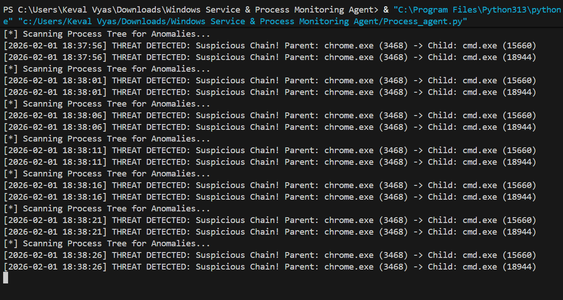
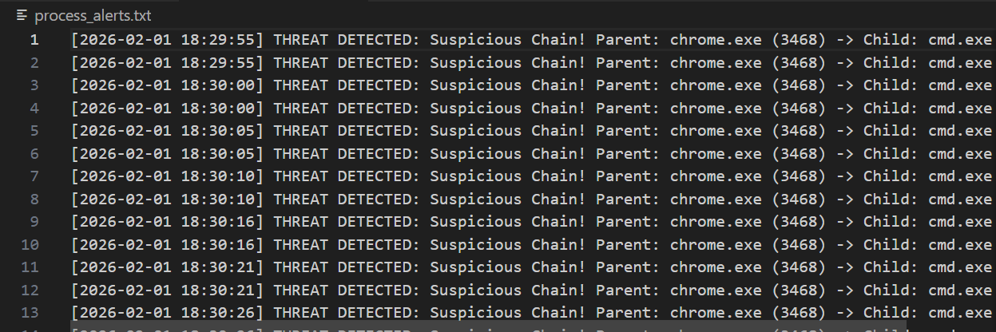

7. Conclusion The "Windows Service & Process Monitoring Agent" successfully demonstrates the principles of Endpoint Detection and Response (EDR). By monitoring parent-child relationships, the tool can identify advanced malware techniques that traditional antivirus might miss .
8. Learning Outcomes Through this project, I learned:
- How Windows manages Process IDs (PIDs) and inheritance.
- How to use Python's psutil to inspect system internals.
- The importance of behavioral analysis in Blue Team operations

